Assignment # 03
CLO 3: Model a solution for a given problem using object oriented principles.

===========================================================================================================
Question: Elaborate different layout managers available in java and also implement all of the available layouts in separate frames to differentiate them.

Layout managers :
The Layout managers enable us to control the way in which visual components are arranged in the GUI forms by determining the size and position of components within the containers.
Type of layout managers
There different type of mangers available in java. Layout managers are explained below.
- GridLayout:
The Java GridLayout class is used to arrange the components in a rectangular grid. One component is displayed in each rectangle.

Constructors of GridLayout class
- GridLayout():
- GridLayout(int rows, int columns):
- GridLayout(int rows, int columns, int hgap, int vgap):
Example
import java.awt.*;
import javax.swing.*;

public class GridLayoutExample
{
JFrame frameObj;

GridLayoutExample()
{
frameObj = new JFrame();

JButton btn1 = new JButton("1");
JButton btn2 = new JButton("2");
JButton btn3 = new JButton("3");
JButton btn4 = new JButton("4");
JButton btn5 = new JButton("5");
JButton btn6 = new JButton("6");
JButton btn7 = new JButton("7");
JButton btn8 = new JButton("8");
JButton btn9 = new JButton("9");

frameObj.add(btn1); frameObj.add(btn2); frameObj.add(btn3);
frameObj.add(btn4); frameObj.add(btn5); frameObj.add(btn6);
frameObj.add(btn7); frameObj.add(btn8); frameObj.add(btn9);

frameObj.setLayout(new GridLayout());

frameObj.setSize(300, 300);
frameObj.setVisible(true);
}

public static void main(String argvs[])
{
new GridLayoutExample();
}
}
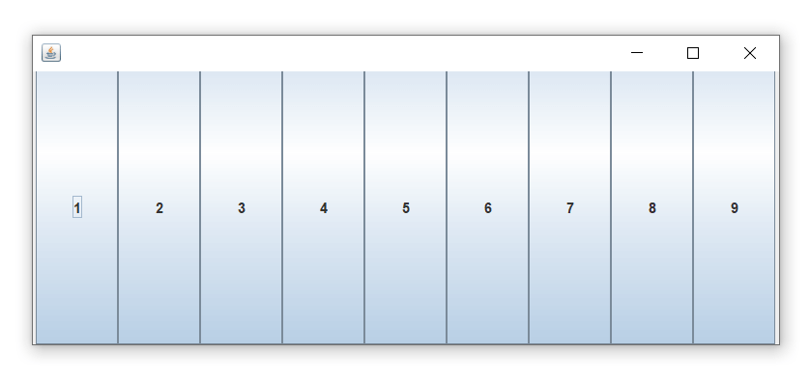
- GridBagLayout:
The Java GridBagLayout class is used to align components vertically, horizontally or along their baseline.The components may not be of the same size. Each GridBagLayout object maintains a dynamic, rectangular grid of cells. Each component occupies one or more cells known as its display area.

Constructor
GridBagLayout():
Example:
import java.awt.Button;
import java.awt.GridBagConstraints;
import java.awt.GridBagLayout;

import javax.swing.*;
public class GridBagLayoutExample extends JFrame{
public static void main(String[] args) {
GridBagLayoutExample a = new GridBagLayoutExample();
}
public GridBagLayoutExample() {
GridBagLayoutgrid = new GridBagLayout();
GridBagConstraints gbc = new GridBagConstraints();
setLayout(grid);
setTitle("GridBag Layout Example");
GridBagLayout layout = new GridBagLayout();
this.setLayout(layout);
gbc.fill = GridBagConstraints.HORIZONTAL;
gbc.gridx = 0;
gbc.gridy = 0;
this.add(new Button("Button One"), gbc);
gbc.gridx = 1;
gbc.gridy = 0;
this.add(new Button("Button two"), gbc);
gbc.fill = GridBagConstraints.HORIZONTAL;
gbc.ipady = 20;
gbc.gridx = 0;
gbc.gridy = 1;
this.add(new Button("Button Three"), gbc);
gbc.gridx = 1;
gbc.gridy = 1;
this.add(new Button("Button Four"), gbc);
gbc.gridx = 0;
gbc.gridy = 2;
gbc.fill = GridBagConstraints.HORIZONTAL;
gbc.gridwidth = 2;
this.add(new Button("Button Five"), gbc);
setSize(300, 300);
setPreferredSize(getSize());
setVisible(true);
setDefaultCloseOperation(EXIT_ON_CLOSE);

}

}
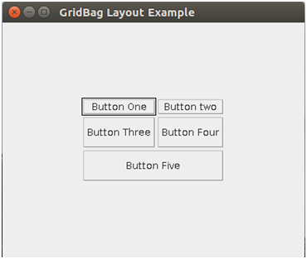

- BoxLayout :
The Java BoxLayout class is used to arrange the components either vertically or horizontally.

Constructor of BoxLayout class
- BoxLayout(Container c, int axis):
Example:
import java.awt.*;
import javax.swing.*;

public class BoxLayoutExample1 extends Frame {
Button buttons[];

public BoxLayoutExample1 () {
buttons = new Button [5];

for (int i = 0;i<5;i++) {
buttons[i] = new Button ("Button " + (i + 1));
// adding the buttons so that it can be displayed
add (buttons[i]);
}

setLayout (new BoxLayout (this, BoxLayout.Y_AXIS));
setSize(400,400);
setVisible(true);
}

public static void main(String args[]){
BoxLayoutExample1 b=new BoxLayoutExample1();
}
}
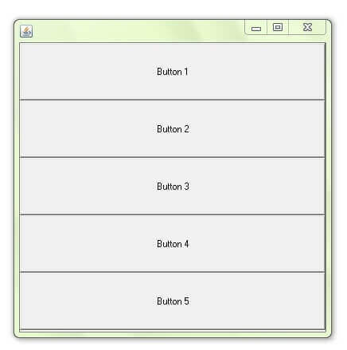

- CardLayout:
The Java CardLayout class manages the components in such a manner that only one component is visible at a time. It treats each component as a card that is why it is known as CardLayout.

Constructors of CardLayout Class
- CardLayout():
- CardLayout(int hgap, int vgap):
Example:
mport java.awt.*;
import javax.swing.*;
import java.awt.event.*;

public class CardLayoutExample1 extends JFrame implements ActionListener
{

CardLayout crd;

// button variables to hold the references of buttons
JButton btn1, btn2, btn3;
Container cPane;

// constructor of the class
CardLayoutExample1()
{

cPane = getContentPane();

//default constructor used
// therefore, components will
// cover the whole area
crd = new CardLayout();

cPane.setLayout(crd);

btn1 = new JButton("Apple");
btn2 = new JButton("Boy");
btn3 = new JButton("Cat");

btn1.addActionListener(this);
btn2.addActionListener(this);
btn3.addActionListener(this);

cPane.add("a", btn1);
cPane.add("b", btn2);
cPane.add("c", btn3);
}
public void actionPerformed(ActionEvent e)
{

crd.next(cPane);
}

public static void main(String argvs[])
{

CardLayoutExample1 crdl = new CardLayoutExample1();

crdl.setSize(300, 300);
crdl.setVisible(true);
crdl.setDefaultCloseOperation(EXIT_ON_CLOSE);
}
}
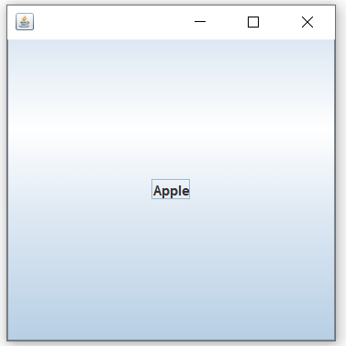

- BorderLayout:
The BorderLayout is used to arrange the components in five regions: north, south, east, west, and center. Each region (area) may contain one component only. It is the default layout of a frame or window. The BorderLayout provides five constants for each region:

Constructors of BorderLayout class:
- BorderLayout():
- BorderLayout(int hgap, int vgap):

Example:
import java.awt.*;
import javax.swing.*;
public class Border
{
JFrame f;
Border()
{
f = new JFrame();
JButton b1 = new JButton("NORTH");
JButton b2 = new JButton("SOUTH");
JButton b3 = new JButton("EAST");
JButton b4 = new JButton("WEST");
JButton b5 = new JButton("CENTER");

f.add(b1, BorderLayout.NORTH);
f.add(b2, BorderLayout.SOUTH);
f.add(b3, BorderLayout.EAST);
f.add(b4, BorderLayout.WEST);
f.add(b5, BorderLayout.CENTER);

f.setSize(300, 300);
f.setVisible(true);
}
public static void main(String[] args) {
new Border();
}
}
